Air Powered Rocket

2.0 The Engineering Design Process
Design, Sketch, to a Model Project
Design Process Project Rubric
Drafting I

Purpose: The purpose of this activity is to give students the opportunity to design a rocket with the aid of the Engineering Design Process. However, your writing skills, critical thinking, model building, and presentation skills will also be needed to complete the task.
Objective: For this project the students will have the option to work with a partner.

The design of your rocket must meet the following criteria:
-Rockets must have a height of 11 inches or more with a diameter of less than 3 inches
-Rocket must launch at-least 30 feet into the air and return to earth with the aid of a parachute
-Rocket must be made of copy paper, clear tape, plastic (for the parachute), and thread

Report Criteria
- Typed (Times New Roman – 12pt)
- Double Space
- Title Page (Title, Name, Class, Teacher)

While gathering information for your report, follow the design process to create sketches, technical drawings (multi-views and isometric), and a to-scale prototype of your solution. All technical drawings must be dimensioned correctly using the dimensioning guidelines from the previous unit. Follow the Design process to make sure you have all the required information in your report. Use the rubric below as a guide to help type of your report and put together your portfolio. (The project is worth 600 points with each step of the Design process is worth 100 points.)
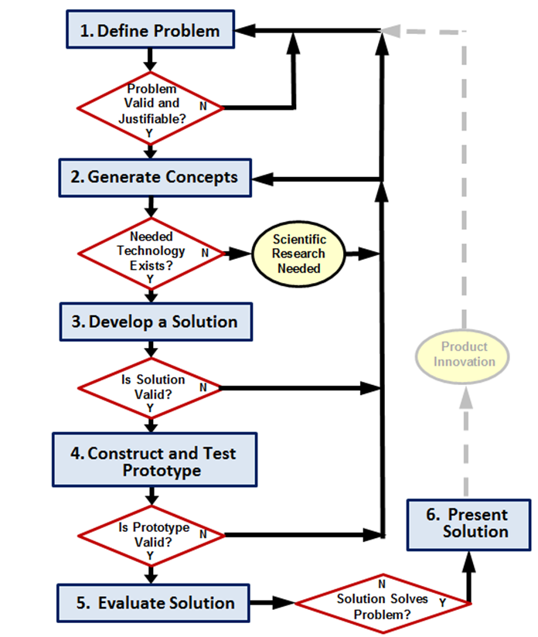
Project Rubric
Design Brief

Define the Problem (100 pts.)

Identify the Problem (25 pts.)

What’s The Problem?

Validate the Problem (25 pts.)

Who says it’s a problem?

What are the needs/wants?

Prior solutions?

Did they renovate before? If so what did they improve on?

Justify the problem (25 pts.)

Is the problem worth solving? Why or Why not?

Design Requirements (25 pts.)

Criteria/ Constraints (Budget, what you can and cannot use)?

Generate Concept (100 pts.)

Brainstorm possible solutions (25 pts.)

Come up and explain in detail at least 3 possible solutions/ideas (Research your solutions to make sure they are possible).

Design Goals (25 pts.)

What are your goals with the solutions you have generated?

What will you do if the goals are not met?

Decision Matrix (25 pts.)

Create a decision matrix for your three possible solutions that you have brain stormed previously

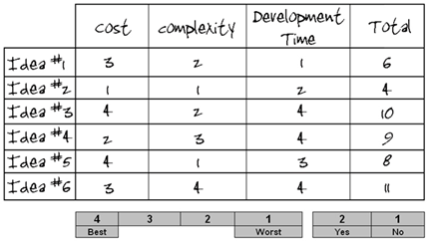
Determine which solution you will choose. Why have you decided to go with this solution? (25 pts.)

Develop a Solution (Create your sketches and Designs) (100 pts.)

Design Sketch, Isometric Sketch, and Multiviews (25 pts.)

Turn ideas into sketches on computer paper

Details (25 pts.)

How will it work?

What materials are you using to construct the product? – Cannot use anything from the example

Budget (How much it cost to construct)? – Cannot exceed $10 to construct

Size and Assembly

Justify your solution (25 pts.)

What makes your solution the best possible solution?

How does it solve the problem presented?

How does it solve the problem?

What makes you certain it will solve the problem?

Construct & Test Prototype (Create your Model) (100 pts.)

What problems did you run into while constructing your product? (25 pts.)

What are your step by step procedures on constructing your product (Include the materials and what they were used for)? (25 pts.)

Include pictures of the construction of your product and the finished product. (25 pts.)

Testing (25 pts.)

Could your product be built? If not, why? (If not go back to the drawing board and re-design)

Does your model include everything that’s on your design? If not, Why?

Does it satisfy all needs and wants? How does it satisfy the customer’s needs and wants?

Evaluate the Solution (100 pts.)

Is it effective? Why or Why not? (50 pts.)

Reflection on Design (50 pts.)

What could you have done different?

Did you encounter any problems during the design/construction process? Why or why not?

What made the building of your prototype successful? If it wasn’t successful, why not?

Does the solution solve the problem? How so? (If not, return back the design process)

Present the Solution (100 pts.)

Communicate the project (Prezi, Presentation/Project Board, PowerPoint)

The following is all the information you are required to present during your presentation:

Title, Name, Block, class (10 pts.)

Identify the problem (What’s the problem? Who says it’s a problem? Needs/Wants?) (10 pts.)

Design Goals (10 pts.)

Decision Matrix (10 pts.)

Design Requirements (10 pts.)

Problems/Challenges (10 pts.)

Sketches (10 pts.)

Technical Drawings (10 pts.)

Pictures of Model and actual Model (10 pts.)

Reflection (10 pts.)

*****In order to present you must be dressed in BUSINESS CASUAL attire the day of presentations. Below are examples of business casual attire for women and men.*****
BUSINESS CASUAL
Men
Tops (Make sure your shirt is tucked in)
- Button ups or polo style shirts
  - Ties, Sweaters, Vests, and cardigans are OPTIONAL
Bottoms
- Khakis, dress pants, or slacks (Make sure you are wearing a belt)
- Dress Shoes or Dress boots

Women
- Skirts and Dresses are acceptable (As long as they are long enough to cover kneecaps)
- Khakis, dress pants, or slacks are acceptable for women also. (Make sure to wear a belt)
- Blouses, plain shirts, sweaters, turtlenecks, vests, and sleeveless shirts are all acceptable.
- dress shoes, flat trouser shoes, high heels; no open toed shoes

