Unit F: Section and Details

Define the following terms related to Section and Details.

- Anchor bolts

- Beam

- Blocking

- Bridging

- Ceiling Joist

- Chords

- Corner Bracing

- Cripple Stud (Jack studs)

- Crawl space

- Cutting plane

- Double Joist

- Double Top Plate

- Drain Tile

- Face grain

- Fascia

- Finished Floor

- Flange

- Flashing

- Flitch beams

- Floor Joist

- Footing

- Foundation Wall

- Girder

- Glulam Beams

- Hatching/Section lining

- Header

- Header (Rim Joist, Butt Joist)

- Insulation

- Joist

- Joist Hanger

- Ledger Strip

- Longitudinal section

- LVL

- O.C.

- OSB

- Particleboard Pier

- Post

- Pressure Treated

- PSL

- Rafter

- Ridge Board

- Sheathing

- Shingles (asphalt)

- Sill (mud sill)

- Soffit

- Sole plate

- Stud

- Stud Wall

- Sub-floor

- Trimmer Stud

- Truss

- Underlayment

- Veneer Construction

- Web

- Weep hole
Unit F: Section and Details
Section and Detail Construction
Identify the following materials with the corresponding numbers in the spaces provided.
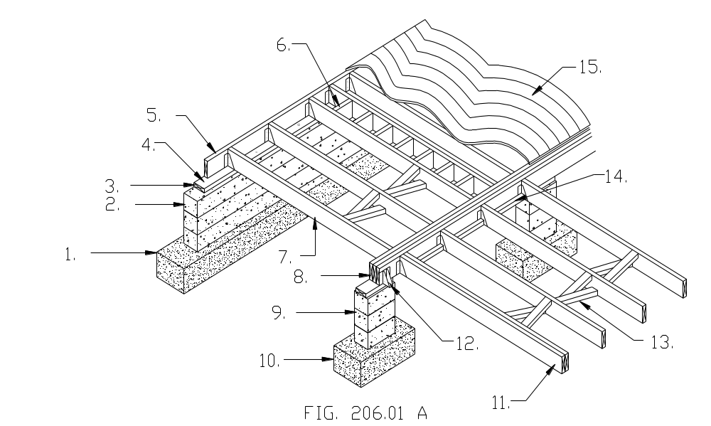
1. 11.
2. 12.
3. 13.
4. 14.
5. 15.
6.
7.
8.
9.
10.

Unit F: Section and Details
Section and Detail Construction
Identify the following materials with the corresponding numbers in the spaces provided.
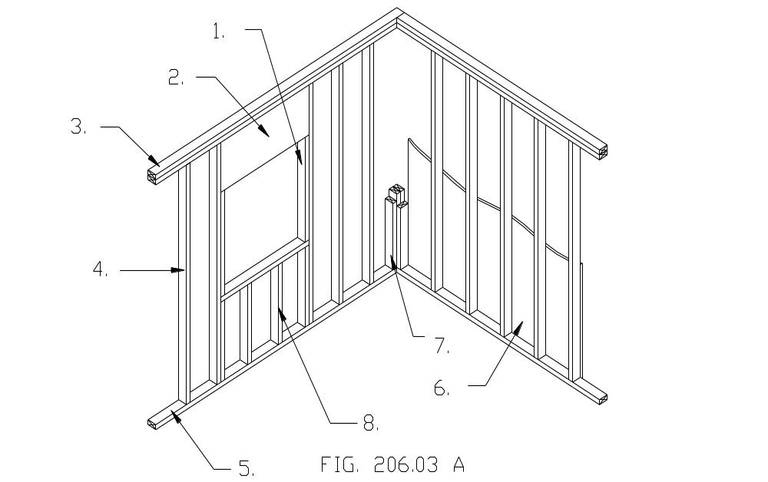
1.
2.
3.
4.
5.
6.
7.
8.

Unit F: Section and Details
Section and Detail Construction
Identify the following materials with the corresponding numbers in the spaces provided.
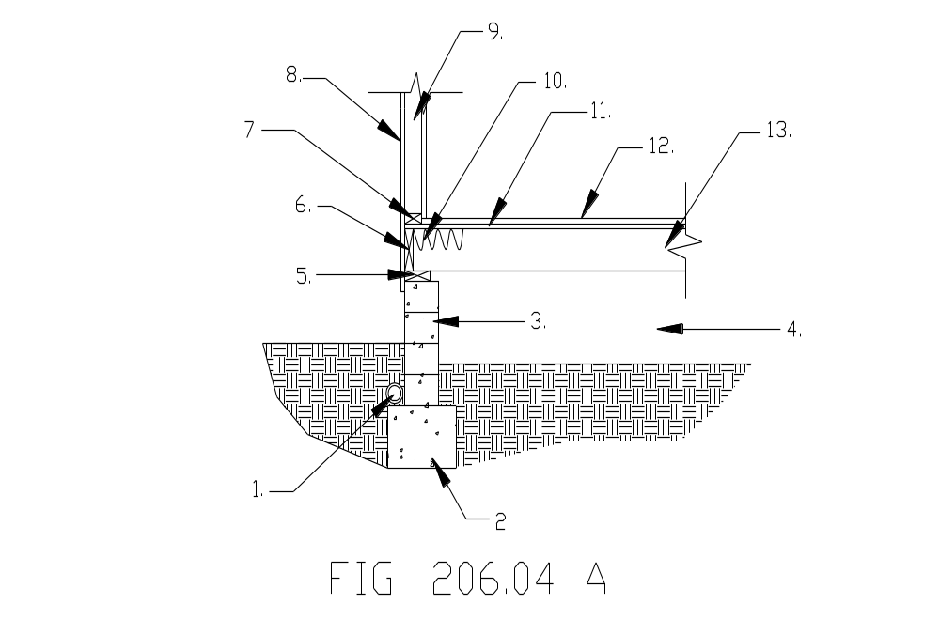

1. 11.
2. 12.
3. 13.
4.
5.
6.
7.
8.
9.
10.

Unit F: Section and Details
Section and Detail Construction
Identify the following materials with the corresponding numbers in the spaces provided.
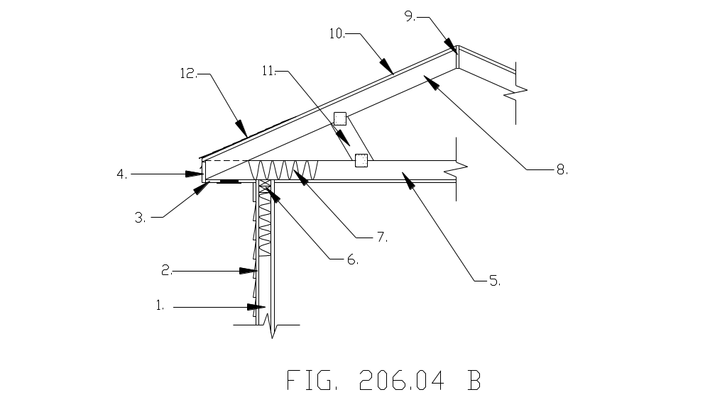
1. 11.
2. 12.
3.
4.
5.
6.
7.
8.
9.
10.

Unit F: Section and Details
Section and Detail Construction
Identify the following materials with the corresponding numbers in the spaces provided.
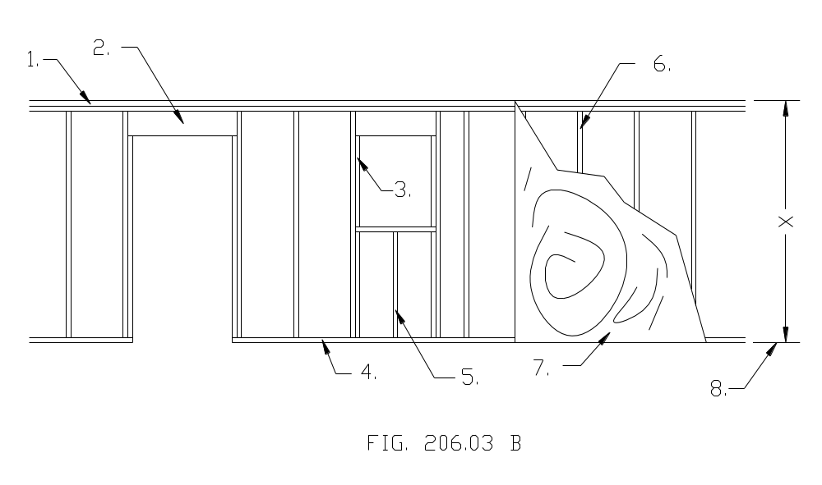
1.
2.
3.
4.
5.
6.
7.
8.

